[--->Step 1: I login as an admin user[PASSED]<---]

[--->Step 2: I navigate to page on admin "Account Purchase Products 1478"[PASSED]<---]

[--->Step 3: I select option "Test Client Behat ( #11609560 )" from contact[PASSED]<---]

[--->Step 4: I select option "Cameron Briggs" from sales person[PASSED]<---]

[--->Step 5: I click on "Add a product"[PASSED]<---]

[--->Step 6: I select option "Job Posting" from product[PASSED]<---]

[--->Step 7: I select option "Resume-Library Testing ( #1360713 )" apply to[PASSED]<---]

[--->Step 8: I select option "Credit Card" from payment type[PASSED]<---]

[--->Step 9: I click on Mark as Paid[PASSED]<---]

[--->Step 10: I click on "Pay Now"[PASSED]<---]

[--->Step 11: I enter city "New York"[PASSED]<---]

[--->Step 12: I fill in "valid" card number[FAILED]<---]
  
[--->Failed Reason:
org.openqa.selenium.NoSuchElementException: no such element: Unable to locate element: {"method":"css selector","selector":"#card\-number\-iframe"}
(Session info: chrome=100.0.4896.127)
For documentation on this error, please visit: https://selenium.dev/exceptions/#no_such_element
Build info: version: '4.6.0', revision: '79f1c02ae20'
System info: os.name: 'Mac OS X', os.arch: 'aarch64', os.version: '13.0.1', java.version: '19'
Driver info: org.openqa.selenium.remote.RemoteWebDriver$ByteBuddy$O0lzmiIJ
Command: [b8936558698018bdc9117500e0ff23e1, findElement {using=id, value=card-number-iframe}]
Capabilities {acceptInsecureCerts: false, browserName: chrome, browserVersion: 100.0.4896.127, chrome: {chromedriverVersion: 100.0.4896.60 (6a5d10861ce8..., userDataDir: C:\Users\ltuser\AppData\Loc...}, goog:chromeOptions: {debuggerAddress: localhost:64392}, goog:loggingPrefs: {browser: ALL}, networkConnectionEnabled: false, pageLoadStrategy: normal, performance: false, platformName: WINDOWS, proxy: Proxy(), se:cdpVersion: 100.0.4896.127, setWindowRect: true, strictFileInteractability: false, timeouts: {implicit: 0, pageLoad: 300000, script: 30000}, unhandledPromptBehavior: dismiss and notify, video: true, webauthn:extension:credBlob: true, webauthn:extension:largeBlob: true, webauthn:virtualAuthenticators: true}
Session ID: b8936558698018bdc9117500e0ff23e1
at java.base/jdk.internal.reflect.DirectConstructorHandleAccessor.newInstance(DirectConstructorHandleAccessor.java:67)
at java.base/java.lang.reflect.Constructor.newInstanceWithCaller(Constructor.java:500)
at java.base/java.lang.reflect.Constructor.newInstance(Constructor.java:484)
at org.openqa.selenium.remote.codec.w3c.W3CHttpResponseCodec.createException(W3CHttpResponseCodec.java:200)
at org.openqa.selenium.remote.codec.w3c.W3CHttpResponseCodec.decode(W3CHttpResponseCodec.java:133)
at org.openqa.selenium.remote.codec.w3c.W3CHttpResponseCodec.decode(W3CHttpResponseCodec.java:53)
at java.base/java.util.function.Function.lambda$andThen$1(Function.java:88)
at org.openqa.selenium.remote.RemoteWebDriverBuilder.lambda$createExecutor$12(RemoteWebDriverBuilder.java:450)
at org.openqa.selenium.remote.RemoteWebDriverBuilder.lambda$createExecutor$13(RemoteWebDriverBuilder.java:456)
at org.openqa.selenium.remote.RemoteWebDriverBuilder.lambda$createExecutor$14(RemoteWebDriverBuilder.java:460)
at org.openqa.selenium.remote.RemoteWebDriverBuilder.lambda$createExecutor$15(RemoteWebDriverBuilder.java:469)
at org.openqa.selenium.remote.RemoteWebDriver.execute(RemoteWebDriver.java:541)
at org.openqa.selenium.remote.ElementLocation$ElementFinder$2.findElement(ElementLocation.java:162)
at org.openqa.selenium.remote.ElementLocation.findElement(ElementLocation.java:60)
at org.openqa.selenium.remote.RemoteWebDriver.findElement(RemoteWebDriver.java:365)
at org.openqa.selenium.remote.RemoteWebDriver.findElement(RemoteWebDriver.java:357)
at org.openqa.selenium.support.pagefactory.DefaultElementLocator.findElement(DefaultElementLocator.java:70)
at org.openqa.selenium.support.pagefactory.internal.LocatingElementHandler.invoke(LocatingElementHandler.java:39)
at jdk.proxy2/jdk.proxy2.$Proxy46.getWrappedElement(Unknown Source)
at org.openqa.selenium.remote.internal.WebElementToJsonConverter.apply(WebElementToJsonConverter.java:51)
at org.openqa.selenium.remote.RemoteWebDriver$RemoteTargetLocator.frame(RemoteWebDriver.java:1020)
at com.resumelibrary.webtest.client.ProductsPage.fillInCardNumber(ProductsPage.java:148)
at com.resumelibrary.cucumber.stepdefinitions.web.client.Products.iFillInCardNumber(Products.java:30)
at ✽.I fill in "valid" card number(file:///Users/shubhamr/Desktop/rl-selenium-web/./src/test/java/resources/featurefiles/admin/misc/PurchaseProducts.feature:19)
<---]  
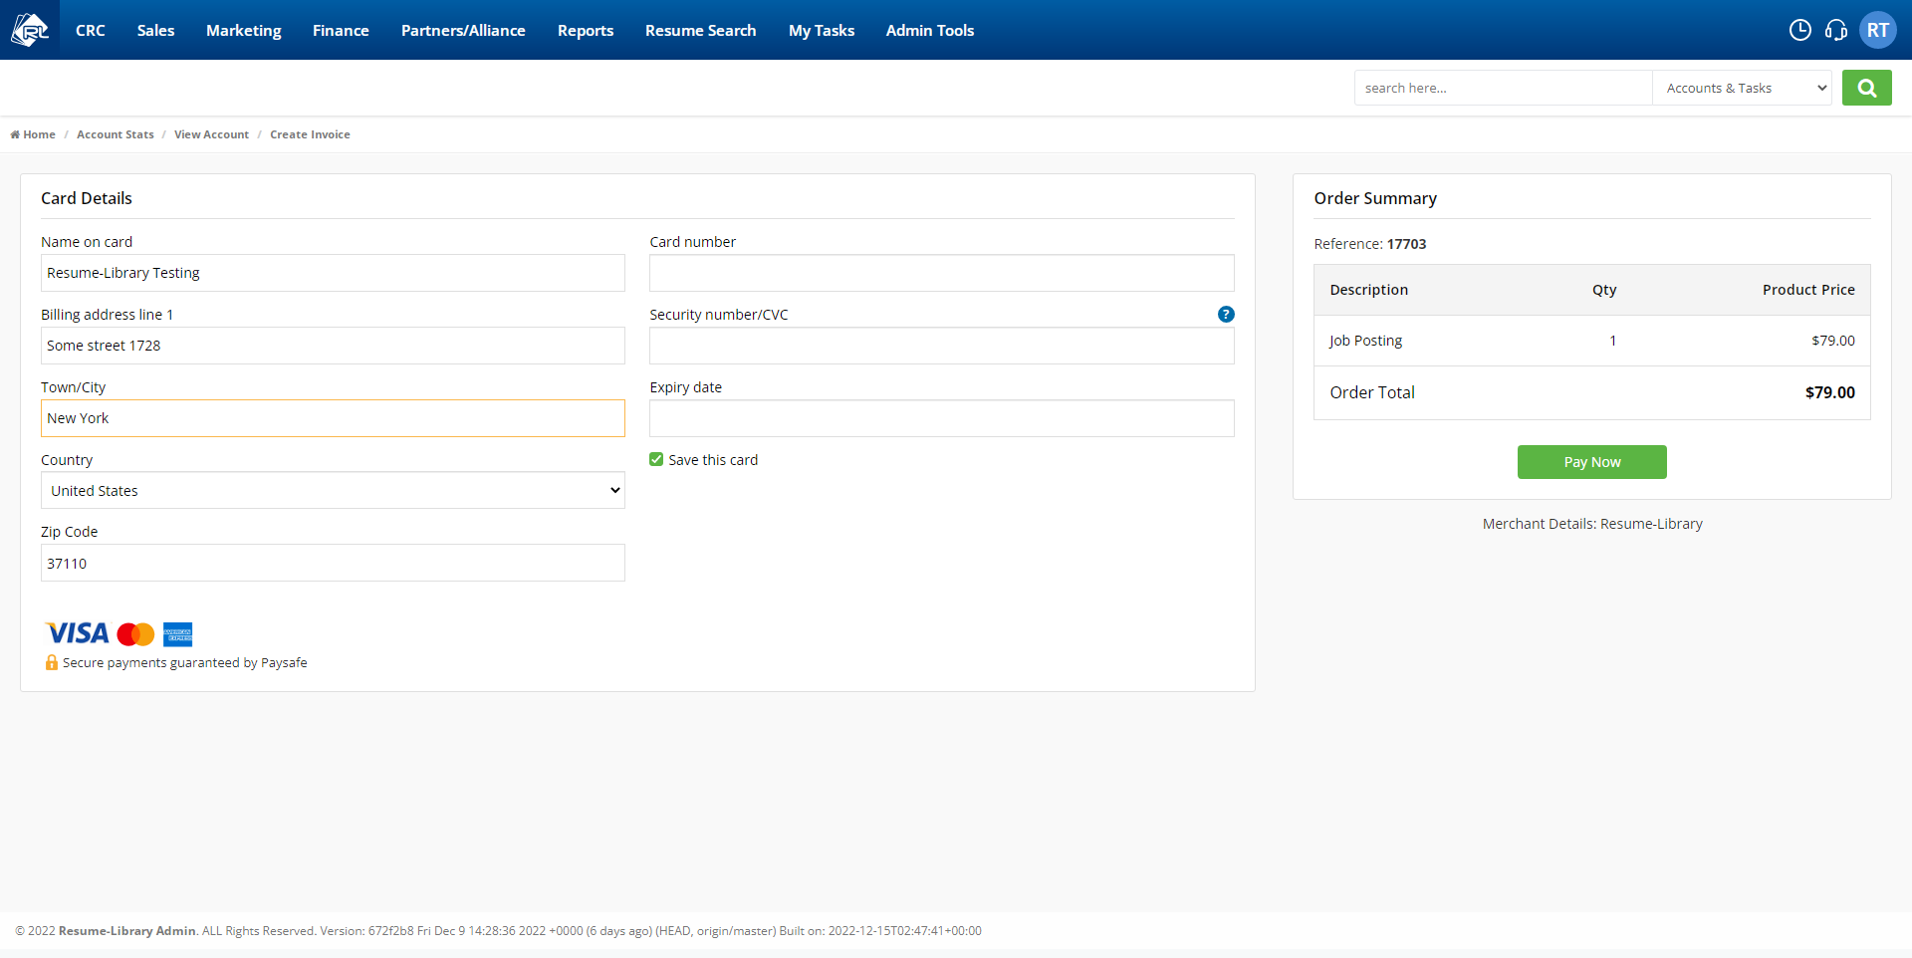

[--->Step 13: I fill in "valid" cvc[SKIPPED]<---]

[--->Step 14: I fill in expiry date[SKIPPED]<---]

[--->Step 15: I click Save this card[SKIPPED]<---]

[--->Step 16: I click Pay Now button[SKIPPED]<---]

[--->Step 17: I should see text H three tag "Confirm payment"[SKIPPED]<---]

[--->Step 18: I click on Confirm payment[SKIPPED]<---]

[--->Step 19: I should see text "Order Confirmation"[SKIPPED]<---]

[--->Step 20: I should see text "The client's purchase has been successful."[SKIPPED]<---]